
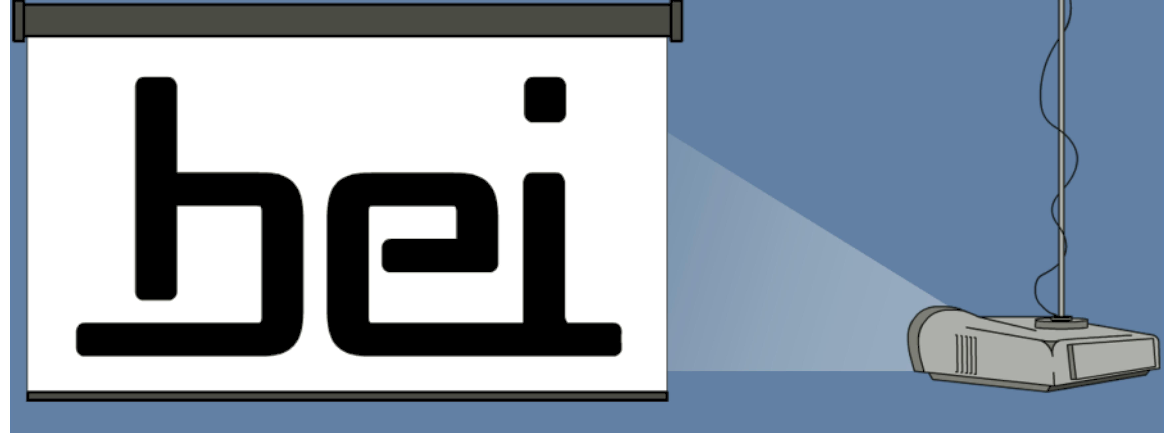
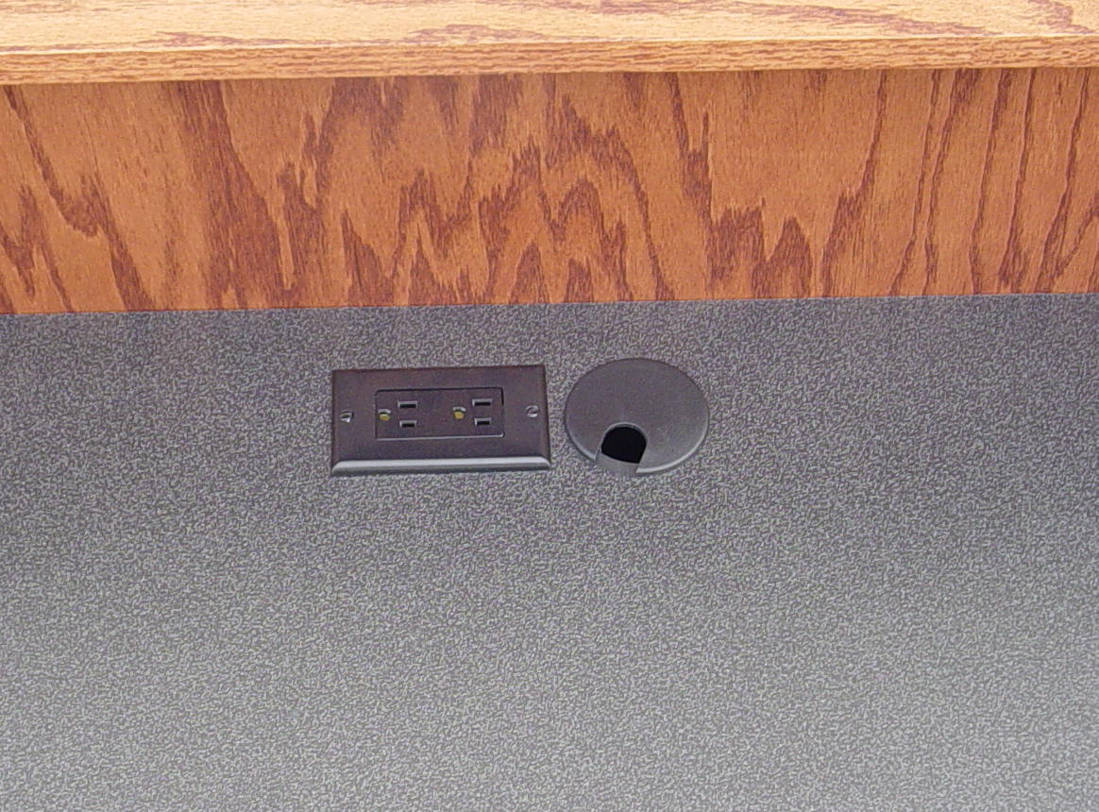
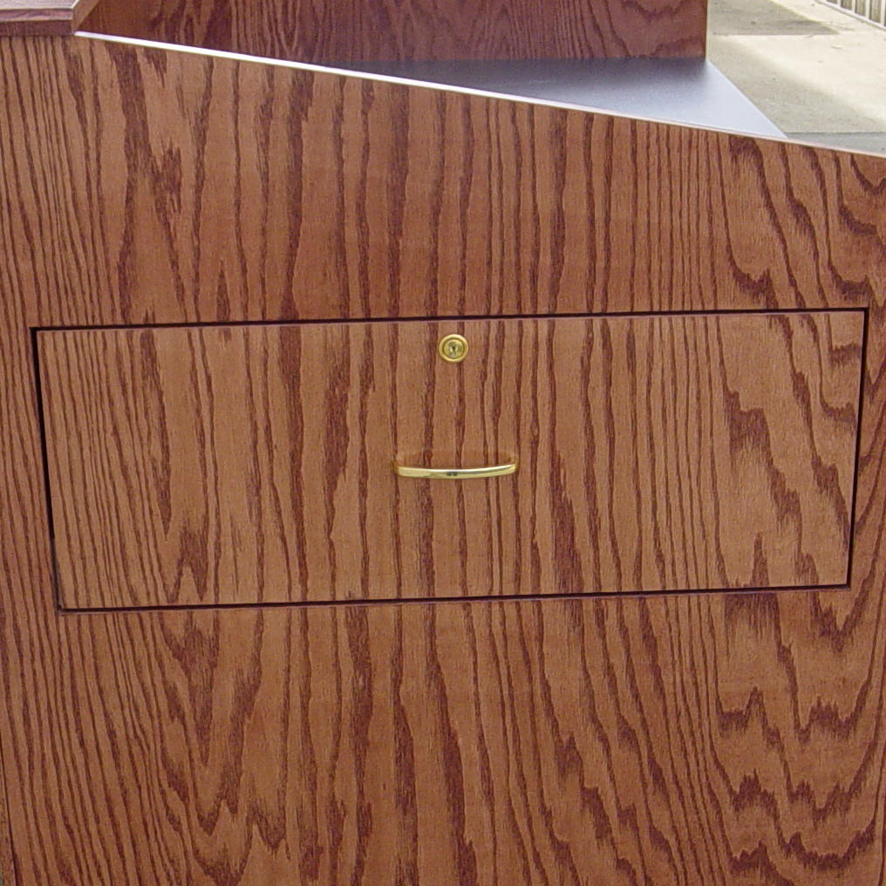
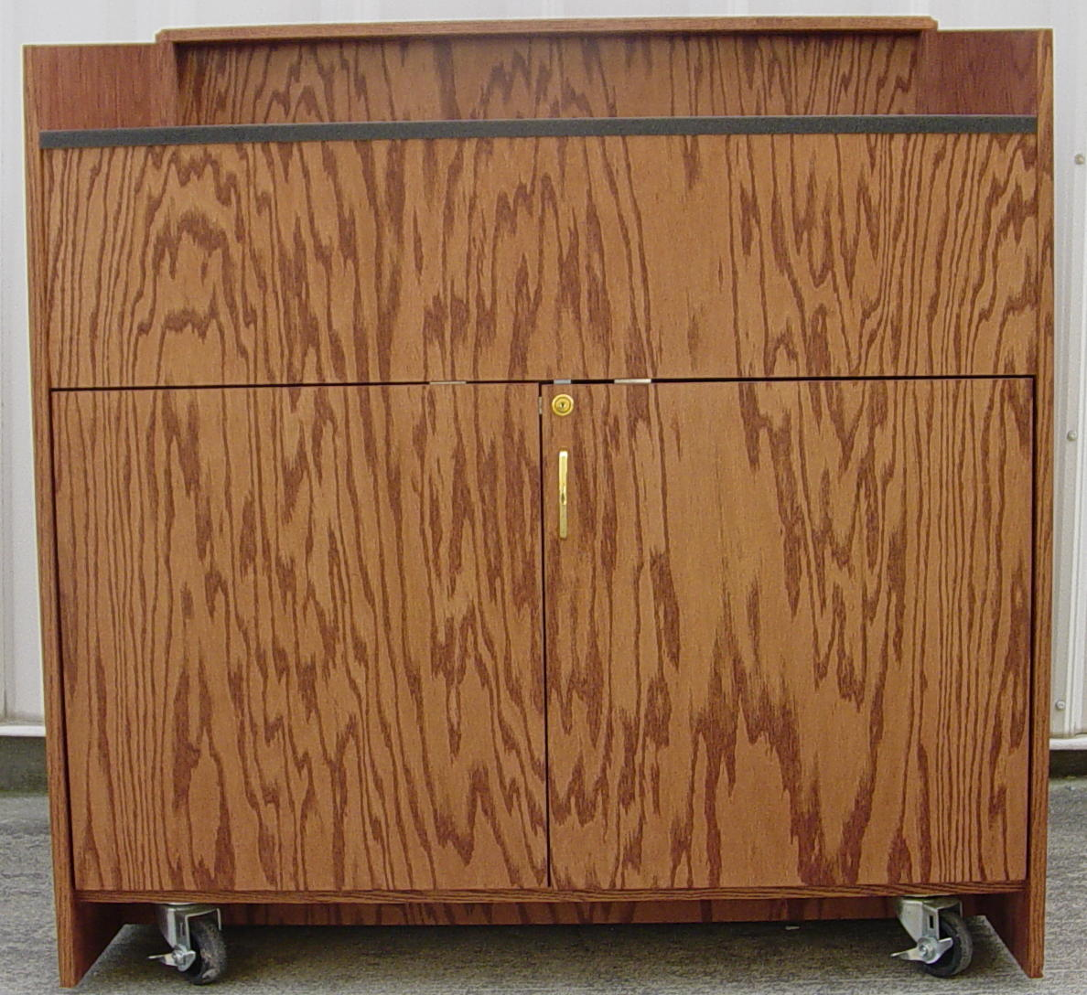
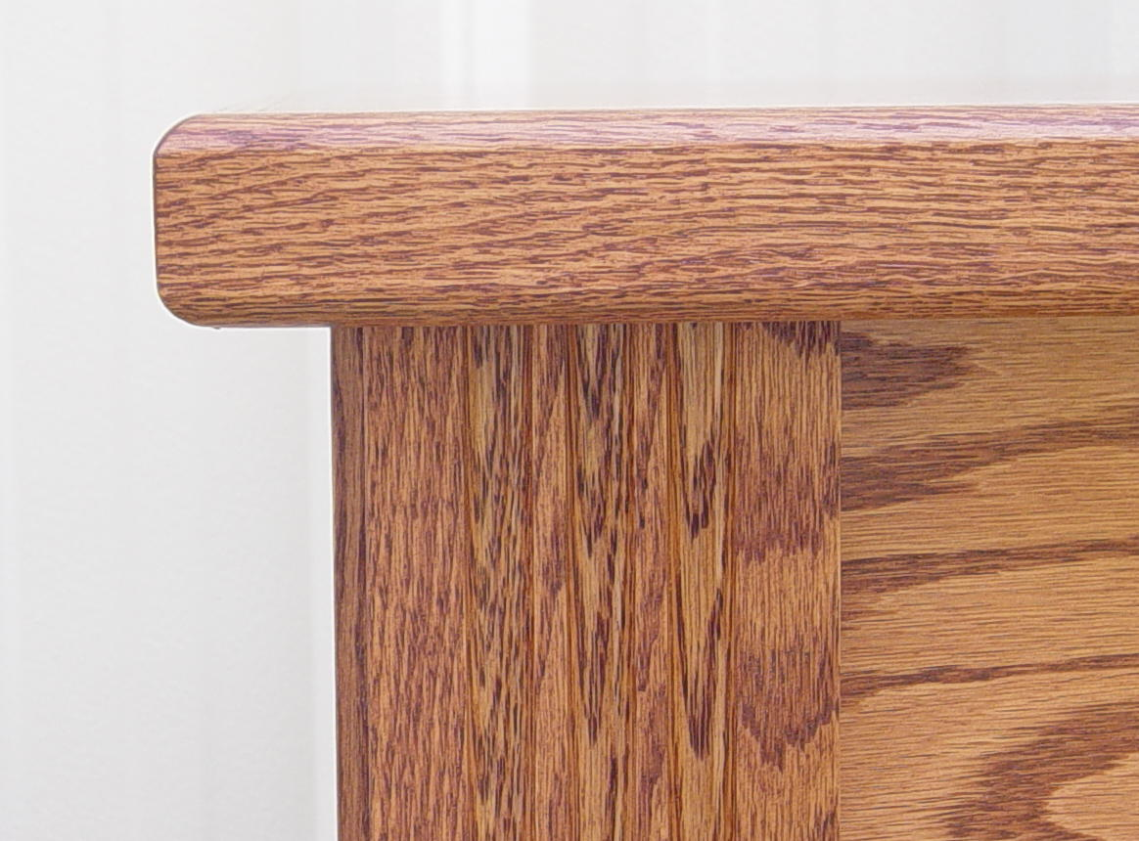
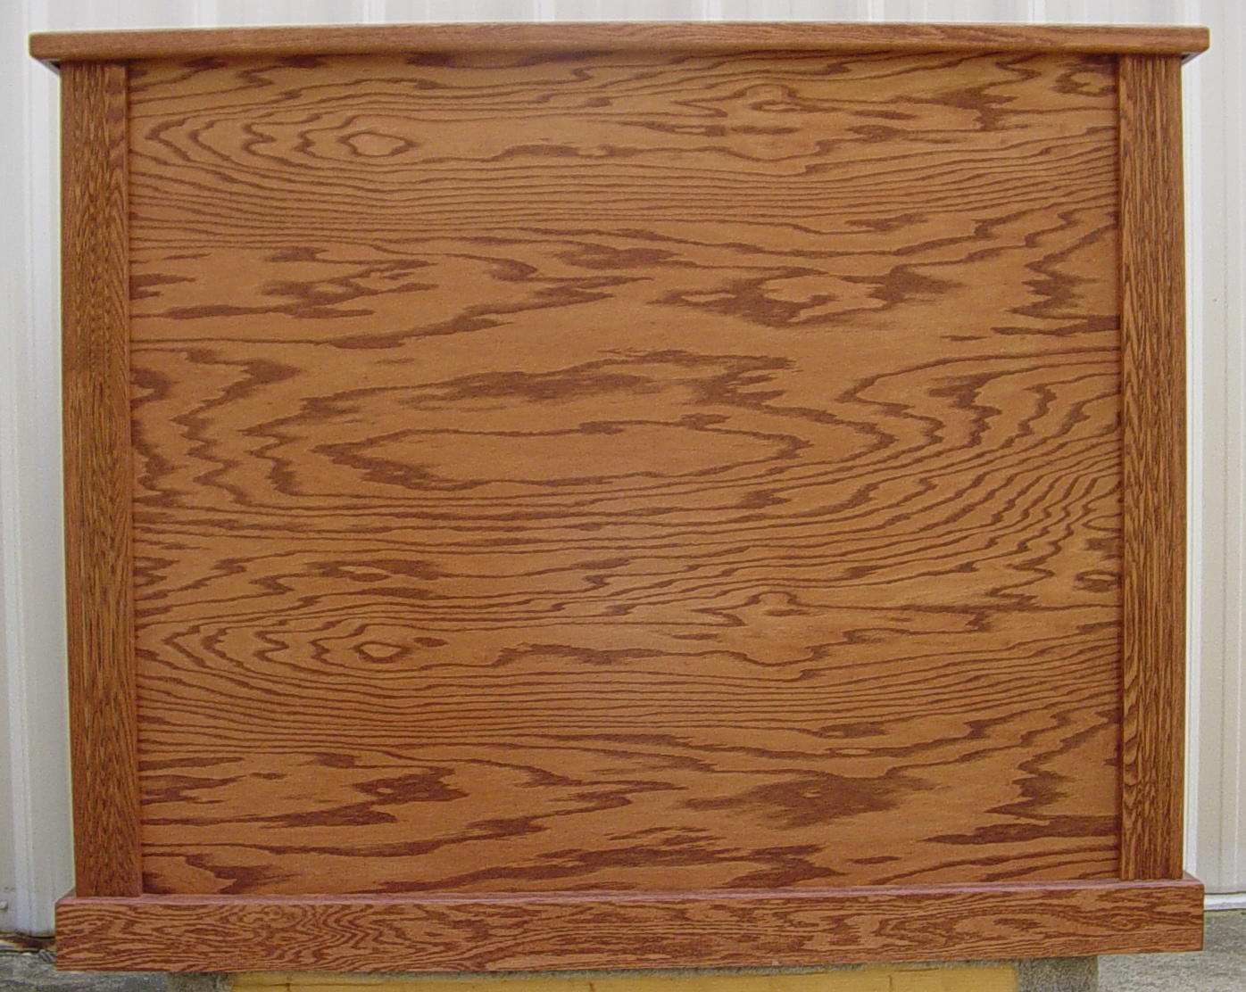
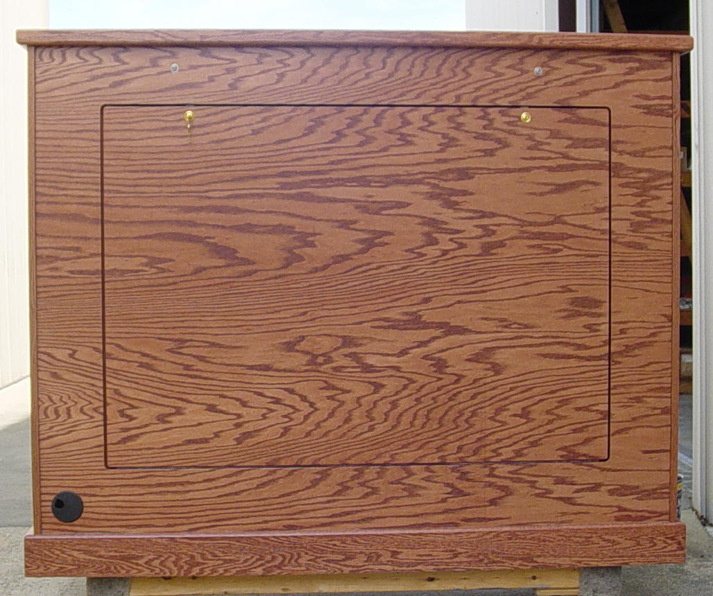
Furniture Sale
First Quality / Available to ship next day
1/ 45” Lectern
- Oak Wood
- Red Oak Stain
- Brass Hardware
- Flat Work Surface
- Locking Doors
- Locking Document Camera Drawer On Left
- Fluted Corners
- AC Outlet In Work Surface
- Grommet In Work Surface
- Grommet In Floorboard

2/ 60” Diag. Plasma Lift Cabinets
- Actual Inside Dimensions
60” Wide x 46” High x 17.5” Deep
- Oak Wood
- Red Oak Stain
- Fluted Corners
- Grommet On Back Left Corner
- Optional Low Voltage Control Available

Front View
Top View
Left Side View
Front View
Fluted Corners
Back View

